THE SCRIPTURES COMPLETE
Lashawam-Qadash Translation Project
Africa and South America
The Joined Continents
Geology, Minerals, Hydrology, Language, Trade Routes, DNA and Geometry
Version 1.0 · October 5, 2026
Governed by Master Rules v18.0 and v19
Faithfulness Over Speed — Quality Over Quantity
Dedicated to Ahlah Shadaya Yahawah AhlahYama Hayahawashai Mawashayai Yaraya

How to read this book
This book presents the findings of THE SCRIPTURES COMPLETE project. Project doctrine is the governing account in every section (Master Rules v18.0 and v19, Part 13).
PROJECT DOCTRINE and PROJECT FINDING: what the project has established from scripture, the Master Rules, the Twelve Families of Yasharahlah document, the Jacob’s Ladder research (December 18, 2025), the project’s geographic proofs and Apostle Ainawayah’s rulings.
SECULAR RECORD (reference): dates, figures and events drawn from outside sources, listed in the Excel workbook. They are included as supporting reference and for dating; they never override a project finding.
Naming. Lashawam-Qadash names follow Master Rules v18.0 and v19 (Ma-Taza-Ra-Ya-Ma, Ba-Ba-La, Ah-Sha-Wa-Ra, Ya-Ha-Wa-Da-Ha, Ya-Ra-Wa-Sha-La-Ma, Ya-Sha-Ma-Ai-La, Qa-Ta-Wa-Ra-Ha, Yasharahlah). Modern country names are used only to locate a place. Titles of outside works are quoted exactly as published.

1. What this book is for
This book gathers the project’s findings that Africa and South America were one land, together with the geological, hydrological, linguistic, trade and genetic points that bear on them. Project findings govern; outside material is included as supporting reference. Gaiah (Ga-Ai-Ah, "motion upon the Father’s breath") is the project’s name for the planet; Haitha (Ha-Ai-Tha) is its confirmed term for "The Mark of the Eye" or "The Covenant Sign Upon." The continents are named here in English.
Two labels run through the book: PROJECT FINDING (what the project teaches, the governing account) and SECULAR RECORD (outside data, listed for reference and for the project to cite or answer). All maps in this book were computed for this project from public-domain Natural Earth country outlines; they are described under each figure.

2. The timeline: when the continents divided
PROJECT FINDING. Africa and South America were one land until the Flood, and they divided during the Flood itself. In the six hundredth year of the life of Na-Khaa, in the second month, on the seventeenth day of the month, all the fountains of the great deep were broken up and the windows of heaven were opened (Genesis 7:11). By His knowledge the depths are broken up (Proverbs 3:20).
PROJECT FINDING. Seven days before the waters came, Yahawah caused the whole earth to shake; the foundations of the world raged, the whole earth was moved violently, and all the fountains in the earth were broken up. At the end of those seven days the waters of the Flood were upon the earth, all the fountains of the deep were broken up, and the rain fell forty days and forty nights (Jasher 6:11-14).
PROJECT FINDING. In the Master Timeline (Master Rules Part 18) the Flood begins in Year 8,000 from Creation, which is 3,470 BC. The breaking up of the great deep, and with it the division of Africa and South America, therefore took place on Month 2, Day 17 of Year 8,000 (3,470 BC), after seven days of violent shaking, and ran through the Flood year until the earth was dried on Month 2, Day 27 of Year 8,001 (3,469 BC; Genesis 8:13-14). The million-year ages given in outside geology, including the 180-million-year figure taken from a secular report in March 2026, cannot be aligned with the Master Timeline and are not used in this book.
Wegener proposed the fit of the continents in 1915, and Bullard, Everett and Smith computed a best fit in 1965 [Wegener1915][Bullard1965].
Event | Scripture | Master Timeline | Gregorian calendar date
Creation | Genesis 1 | Year 0 | 11,470 BC
The 126-year warning given to Ma-Tha-Wa-Sha-La-Khaa and Na-Khaa | Jasher 5:6-11 | Year 7,874 | 3,596 BC
The whole earth shaken and moved violently for seven days | Jasher 6:11-13 | Year 8,000, the seven days before Month 2, Day 17 | 3,470 BC
Fountains of the great deep broken up; Africa and South America divide | Genesis 7:11; Proverbs 3:20; Jasher 6:14 | Year 8,000, Month 2, Day 17 | 3,470 BC
The earth dried; the Flood year ends | Genesis 8:13-14 | Year 8,001, Month 2, Day 27 | 3,469 BC

3. Our computed fit
We rotated South America onto Africa by a least-squares fit between their Atlantic coastlines. The best pole was 48.4 degrees N, 33.1 degrees W, with a rotation of 59.0 degrees; the average coastline mismatch is about 233 km. For comparison, Bullard et al. (1965) gave 44.0 degrees N, 30.6 degrees W, 57.0 degrees [Bullard1965]; our fit is close to it, and the difference reflects our use of modern coastlines rather than the 500-fathom depth contour that the 1965 authors used. The Brazilian bulge sits in the Gulf of Guinea, and the northern coast of South America lines up against the Guinea coast.
Method note: the fit uses modern coastlines, so the continental shelves and the Niger and Amazon deltas show as small overlaps and gaps.
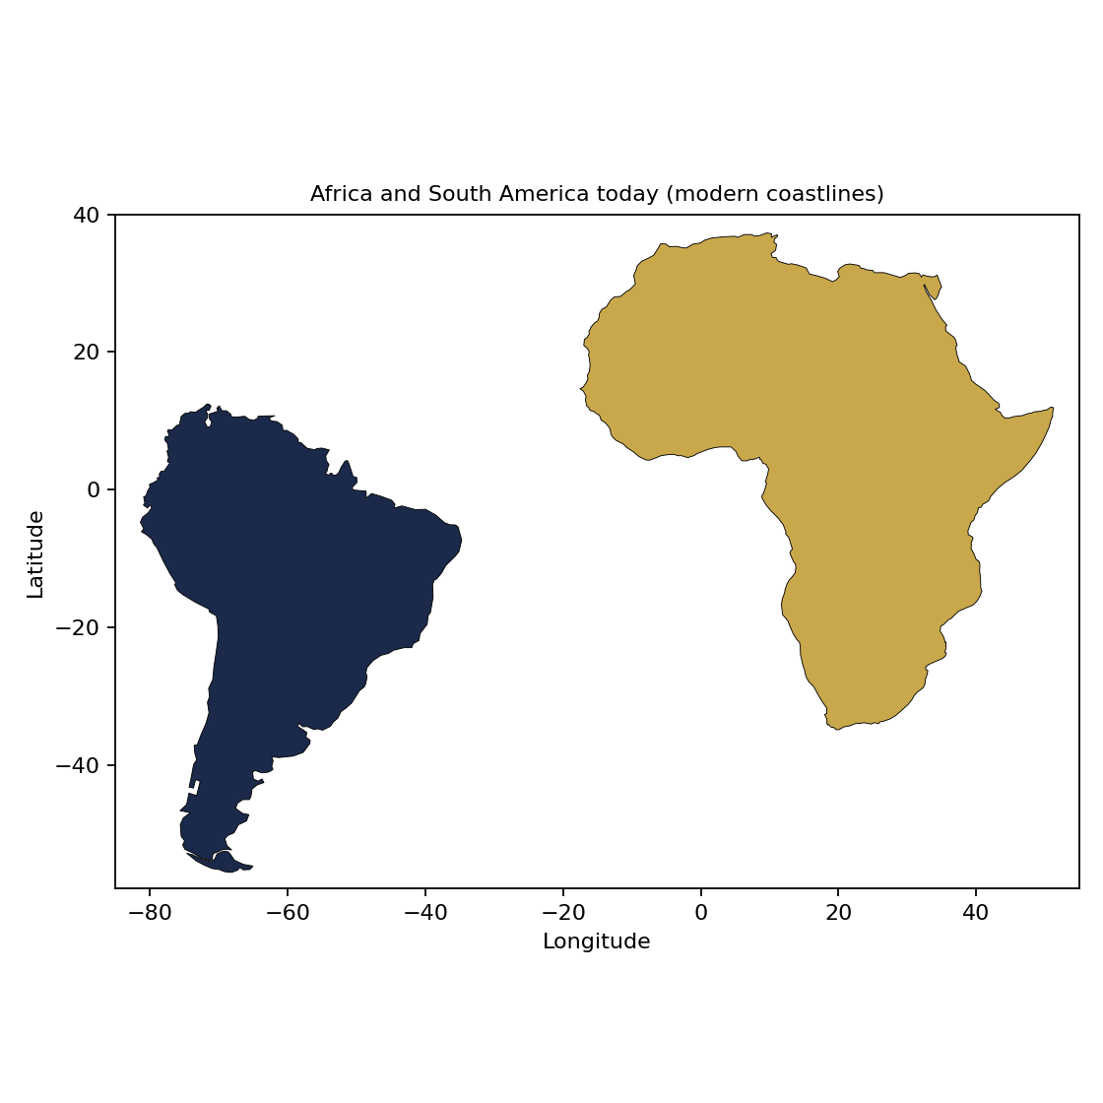
Figure 1. Africa and South America today.
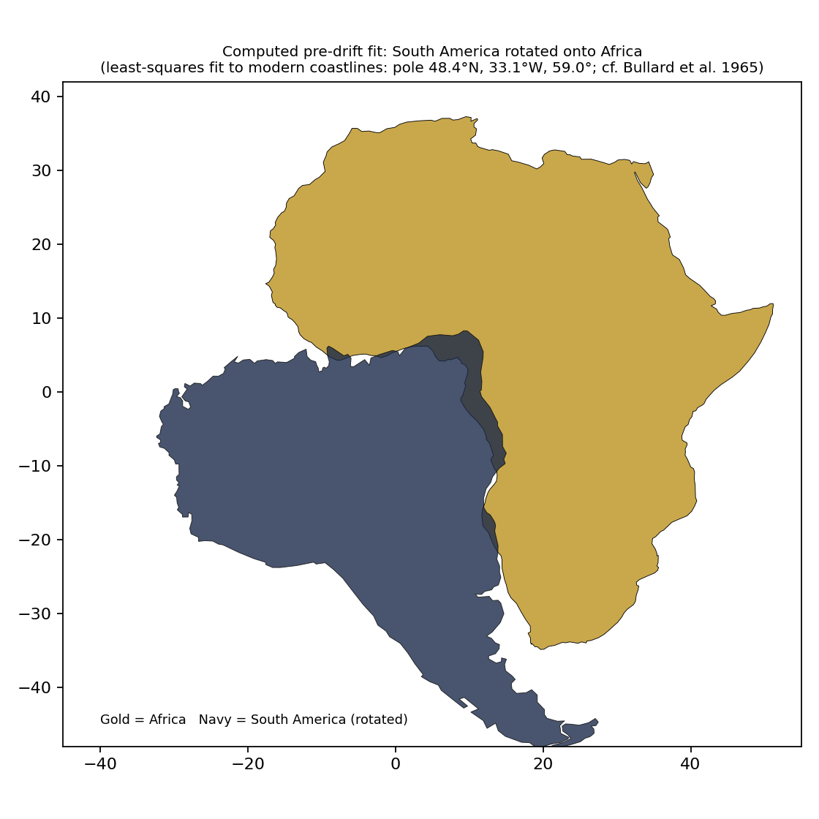
Figure 2. South America rotated onto Africa by a least-squares coastline fit (computed for this project).

4. Geological continuity across the Atlantic
PROJECT FINDING. Africa and South America were one land, and the same ground, ore belts and river systems run through both. The project places Eden (Ga-Na Ai-Da-Na) in the Alantika Mountains and Zion (Ha-Ra Ah-La-Ha) in the Mandara Mountains, at the centre of the Gulf of Guinea side of that joined land.
SECULAR RECORD. Outside geology correlates several ancient rock provinces across the Atlantic: the Birimian belts of West Africa (Ghana, Cote d’Ivoire, Burkina Faso, Guinea) with the Transamazonian belts of the Guiana Shield (Guyana, Suriname, French Guiana, Venezuela, northern Brazil) [Milesi1992][Ledru1994]; the Congo craton with the Sao Francisco craton [Ledru1994]; and the Pan-African belts of Nigeria and Benin with the Borborema Province of north-eastern Brazil [Caby1989]. The Benue Trough of Nigeria is described as a rift arm of the South Atlantic opening, with counterparts in the Reconcavo-Tucano-Jatoba rifts of Brazil [Guiraud1992][Fairhead1991].
Our computation places the rift basins of the Gulf of Guinea and of Brazil’s Reconcavo and Sergipe-Alagoas within about 480-560 km of each other in the reconstruction (Table 2). The gold, iron, bauxite and diamond sites fall about 650-3,000 km apart because each province is a large belt and the site locations are single approximate points; read Table 2 as direction of match.

5. Mineral deposit sharing
PROJECT FINDING. The two continents share one mineral inheritance. Gold, iron, manganese, bauxite and diamond provinces on one side have matching provinces on the other, and the project teaches that the people who worked the Gold Coast mines worked the same ground on the South American side.
SECULAR RECORD. Outside sources describe gold in the Birimian and Transamazonian greenstone belts, the Tarkwa and Jacobina gold districts, banded iron formations, manganese basins and the diamond-bearing cratons as matching provinces across the Atlantic [Milesi1992][Ledru1994]. Bauxite is a surface weathering product of both tropical belts. Offshore, the salt and rift basins of Brazil’s Santos and Campos areas and of Angola, Congo and Gabon are paired margins, and the Gulf of Guinea holds major petroleum systems [Brownfield2006].
PROJECT FINDING. The project’s research established identical mineral chemistry in the matching provinces on both sides of the Atlantic (Book prep, March 2026).
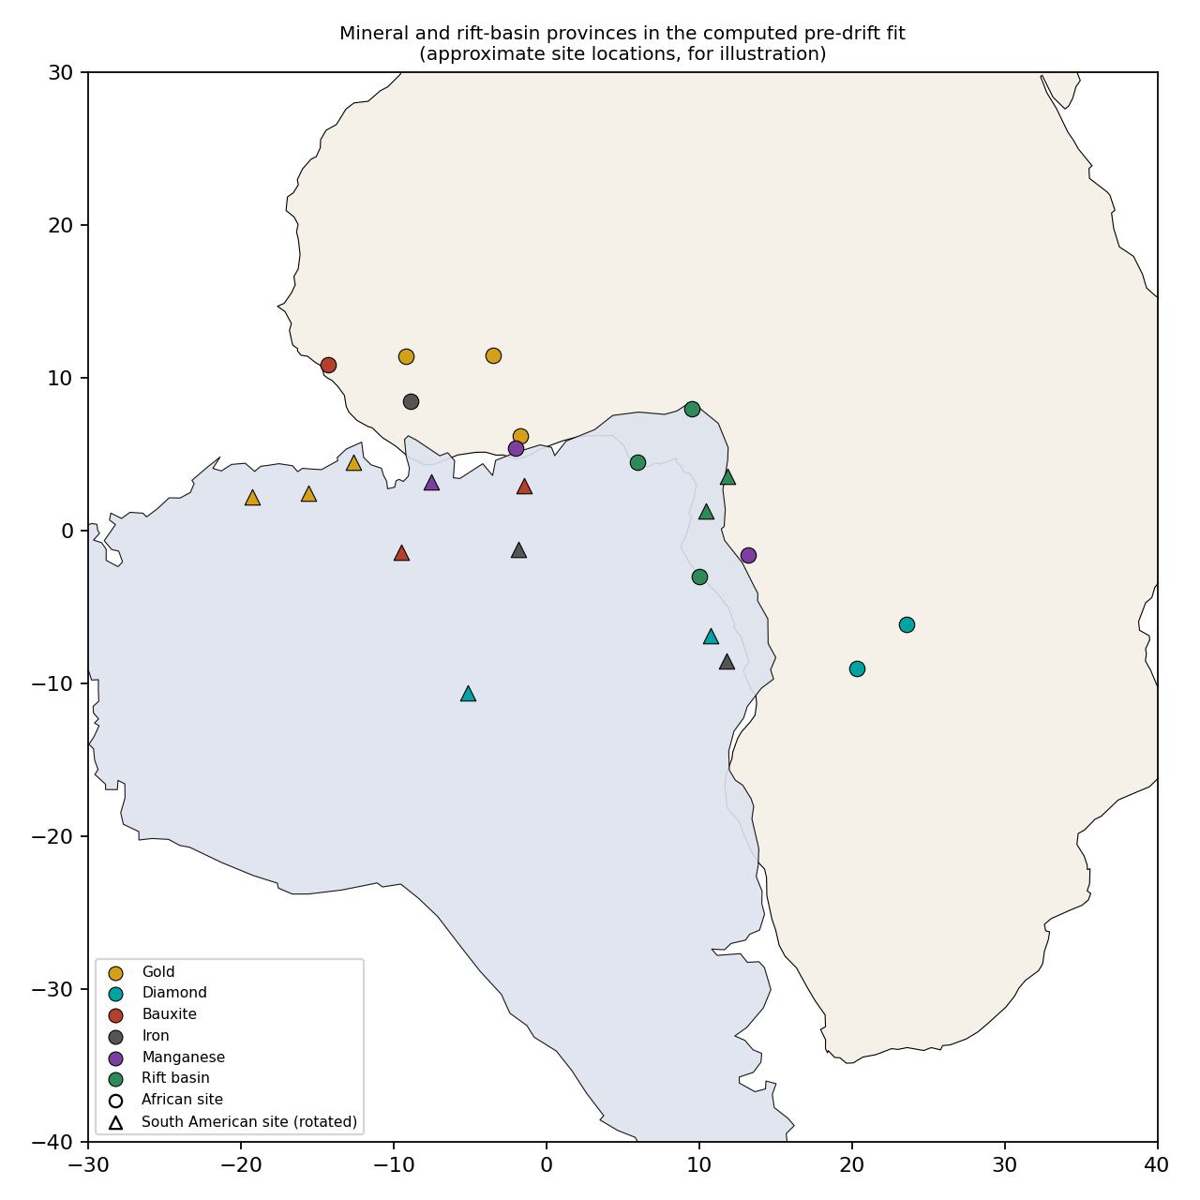
Figure 3. Mineral and rift-basin provinces in the computed fit. Site locations are approximate points; circles are African sites, triangles are South American sites rotated onto Africa.
Table 2. Distance in the reconstruction from each South American site to the nearest African site of the same type (computed; approximate).
South American site | Type | Nearest African site | Distance (km)
El Callao, Venezuela | Gold | Siguiri, Guinea | 1508
Omai, Guyana | Gold | Siguiri, Guinea | 1221
Rosebel, Suriname | Gold | Siguiri, Guinea | 858
Diamantina, Brazil | Diamond | Lunda, Angola | 1076
Juína, Brazil | Diamond | Lunda, Angola | 2792
Trombetas, Brazil | Bauxite | Boké, Guinea | 1467
Paragominas, Brazil | Bauxite | Boké, Guinea | 1668
Carajás, Brazil | Iron | Simandou, Guinea | 1335
Quadrilátero Ferrífero, Brazil | Iron | Simandou, Guinea | 2976
Serra do Navio, Brazil | Manganese | Nsuta, Ghana | 660
Recôncavo-Tucano, Brazil | Rift basin | Gabon-Congo coast | 482
Sergipe-Alagoas, Brazil | Rift basin | Benue Trough, Nigeria | 557

6. Hydrology: waterways and basins
PROJECT FINDING. Eden’s four rivers rise in the Alantika-Mandara watershed, and the great river systems of the joined land are one network. The project’s river identifications are Pison = Benue-Niger (west), Gihon = Chari-Chad (north), Hiddekel = Logone (east) and Euphrates = Sangha-Congo (south). Four feeder streams rise at the watershed: the Mayo-Louti, Mayo-Wanday, Fergo and Kaliao, draining north to the Lake Chad basin and south to the Benue (The four rivers file).
SECULAR RECORD. Outside sources describe the Benue Trough and the Brazilian rift basins as one system when the continents touched [Guiraud1992][Fairhead1991], and describe the Amazon as reversing to flow east after the Andes rose [Hoorn2010][Figueiredo2009]. The Logone joins the Chari at N’Djamena, and the Mayo-Kebbi and Lake Tuburi link the Benue and Chad basins in the wet season, so the Mandara-Alantika watershed joins the Niger-Benue and Chad systems.
Basin | Continent | Note
Niger-Benue | Africa | Benue Trough is a failed rift arm of the Atlantic opening [Guiraud1992]
Lake Chad (Chari-Logone) | Africa | Inland basin; linked to the Benue by the Mayo-Kebbi and Lake Tuburi in the wet season
Congo | Africa | Large equatorial basin on the Congo craton
Amazon | South America | Flows east to the Atlantic opposite the Gulf of Guinea [Hoorn2010]
Orinoco | South America | Drains the Guiana Shield and its Transamazonian belts
Sao Francisco | South America | Flows along the Sao Francisco craton; Reconcavo rift on its eastern margin

7. Language and linguistic connections
PROJECT FINDING. West African and Caribbean and South American words share forms because the peoples are one family. The project offers the Mande kani or ghanin and the Taino guanin (a gold-copper alloy) as one example, and teaches that Bantu languages spread from the Nigeria-Cameroon region, the Alantika and Mandara highlands.
SECULAR RECORD. Outside sources record African languages in the Americas: Palenquero in Colombia (Kikongo roots), Saramaccan and Sranan in Suriname (Kikongo, Fon and Akan), Gullah in the Carolinas, Yoruba in Lucumi (Cuba) and Nago (Brazil), Fon words in Haitian Vodou, and Kikongo and Kimbundu words in Brazilian Portuguese [Holm1988][Turner1949][Lipski2005][Castro2001]. On Bantu origins see [Vansina1990][Greenberg1963]. For the Guanin word and metal see [VanSertima1976] and [Oliver2009].

8. Trade routes
PROJECT FINDING. The Atlantic was a corridor, and the Twelve Families crossed it before and after the slave trade. The North Equatorial Current carries ships from the Senegambian coast to the Caribbean and the Amazon mouth, and the project teaches that Mansa Abu Bakr II sent 2,000 ships into it in 1311.
SECULAR RECORD. Trans-Saharan routes (Niger bend and Hausaland to Morocco, Tripoli and Ma-Taza-Ra-Ya-Ma), the Nile and Red Sea route, the Indian Ocean route, and the triangular Atlantic trade are described in [Austen1979] and [Eltis2010]. The 1311 voyage is recorded by al-Umari from Mansa Musa’s account in Cairo in 1324 [Levtzion1981].

9. DNA ties
PROJECT FINDING. E1b1a (E-M2, parent clade E-V38) is the shared paternal marker of the Twelve Families, with sub-clades for each family (see the family books). The project teaches that five families reached the Americas before Columbus, and that the Original Caribs, Seminole and North American Indian nations are Yasharahlah.
SECULAR RECORD. Outside studies trace African ancestry in the Americas to regions that match the shipping records [Micheletti2020][Gouveia2020], and place the spread of E1b1a with the Bantu expansion from the Nigeria-Cameroon region [BerniellLee2009]. E1b1a is carried on the Y chromosome from father to son, and it is the male line that the project traces through the Twelve Families.

10. Land mass, geometry and geographic components
PROJECT FINDING. In the joined land, the Gulf of Guinea fit places Nigeria and Cameroon (Eden and Zion) at the centre, and the geometry supports the African location of Eden.
SECULAR RECORD. Africa covers about 30.4 million square kilometres and South America about 17.8 million. Our reconstruction (Figure 2) shows the Brazilian bulge in the Gulf of Guinea, the Guinea coast against northern South America, and southern Africa against the Argentine margin, with an average coastline mismatch of 233 km.

11. Project findings register
Project finding | Basis and supporting reference
The Brazilian bulge fits the Gulf of Guinea | Project research; Figure 2; [Bullard1965]
Africa and South America were one land and divided during the Flood, when the fountains of the great deep were broken up (Year 8,000, Month 2, Day 17; 3,470 BC) | Genesis 7:11; Proverbs 3:20; Jasher 6:11-14; Master Rules Part 18
Identical mineral chemistry in the matching provinces | Book prep, March 2026; [Milesi1992][Ledru1994]
The Mandara-Alantika watershed joins the Niger-Benue and Chad systems (Eden’s four rivers) | The four rivers file; Master Rules Part 12.3
Guanin alloy (18 gold : 6 silver : 8 copper) traced to the Bambuk and Boure mines | Book prep, March 2026; [VanSertima1976]
Columbus recorded black merchants from the south and south-east | Book prep, March 2026; [VanSertima1976]
Mansa Abu Bakr II sent 2,000 ships into the Atlantic in 1311 | al-Umari [Levtzion1981]
The Amazon was named for Benjamite warrior women | Book prep, March 2026
Terra preta (dark earth) came from West Africa | Book prep, March 2026; [Glaser2004][Fairhead2009]
Five families were in the Americas before Columbus | Book prep, March 2026
Gad is mixed and Reuben is unmixed | Jacob’s Ladder research; Book prep, March 2026
E1b1a sub-clades mark the male lines of the Twelve Families | Project testing; Jacob’s Ladder: The True Missing Link (December 18, 2025)

11A. The two territories and this book
PROJECT FINDING. The Twelve Families held two distinct territories on two continents, divided by the Jordan River, which the project identifies with the Suez Canal. West of the Jordan, in Africa, lies the Land of Milk and Honey, the Southern Kingdom. East of the Jordan, in Asia, lies the Land of Inheritance, the Northern Kingdom: the Levant, called Palestine today (Master Rules Part 12).
PROJECT FINDING. The Land of Milk and Honey is West Africa below the Sahara together with Central Africa, the original Ethiopian area, down to the northern border of South Africa, with the Mandara and Alantika mountains as the core of Eden and Zion. It is the Southern Kingdom of Ya-Ha-Wa-Da-Ha: modern Nigeria, Ghana and the surrounding region, the primary territory of the Twelve Families (Master Rules Part 12).
PROJECT FINDING. The Northern Kingdom was founded east of the Jordan. Ra-Ah-Wa-Ba-Na (Reuben), Ga-Da (Gad) and the half-tribe of Ma-Na-Sha-Ha (Manasseh) asked for the conquered land of Sihon and Og, and Ma-Sha-Ha gave it to them reluctantly, on condition that their armed men cross over first (Numbers 32). Yahawashai held them to that pledge and they crossed armed before their brethren (Yahawashai chapters 1 to 6). Ah-Pa-Ra-Ya-Ma (also written Khaa-Pa-Ra-Ya-Ma; Ephraim) later governed it. The Land of Inheritance runs from the Jordan River to Mount Hor (Master Rules Part 12).
Statement | Scripture
The promised land flows with milk and honey | Exodus 3:8, 17; Numbers 13:27; Deuteronomy 6:3
The promise runs from the river of Ma-Taza-Ra-Ya-Ma to the great river Euphrates (the Sangha-Congo system in the project’s geography) | Genesis 15:18; Master Rules Part 12
Sha-Ma’s allotted portion, the inheritance of his line | Jubilees 8:12-21
Eden is watered by four rivers parting from one source | Genesis 2:10-14
Zion is the city of Da-Wa-Da and the mountain Yahawah loved | 2 Samuel 5:7; 1 Kings 8:1; Psalm 78:68
The Jordan divides the two lands, and the crossing runs from east to west | Numbers 32:5, 19; Yahawashai 1:2; 3:14-17
Reuben, Gad and half of Manasseh asked for the land east of the Jordan, and Ma-Sha-Ha rebuked the request | Numbers 32:1-15
The grant was conditional: their armed men must cross first and fight for their brethren | Numbers 32:16-32; Deuteronomy 3:18-20
Ma-Sha-Ha gave them the kingdoms of Sihon and Og, east of the Jordan | Numbers 32:33-42; Deuteronomy 3:12-17
Two tribes and a half received their inheritance on this side Jordan, eastward | Numbers 34:13-15
The border runs to Mount Hor | Numbers 34:7-8
Yahawashai held the eastern tribes to their pledge, and they crossed armed before their brethren | Yahawashai 1:12-18; 4:12-13
The crossing ended at Gilgal and Jericho, west of the Jordan | Yahawashai 4:19; 5:10; 6:1-27
Ma-Sha-Ha died in Moab, east of the Jordan, and saw the land but did not enter it | Deuteronomy 34:1-6
The kingdom divided: the north under Jeroboam, an Ephraimite; Ya-Ha-Wa-Da-Ha and Ba-Na-Ya-Ma-Na in the south, with La-Wa-Ya joining them | 1 Kings 11:26; 12:16-21; 2 Chronicles 11:13-14
Ah-Pa-Ra-Ya-Ma governed the Northern Kingdom | Isaiah 7:8-9; Hosea 4:17; 5:3
Mount Sinai, where the Law was given, is in Arabia | Galatians 4:25
The two lands lay far apart: the census of Da-Wa-Da took nine months and twenty days | 2 Samuel 24:4-8
Nineveh and Assyria in Asia are excluded from the inheritance | Zephaniah 2:13-15; Genesis 25:1-18

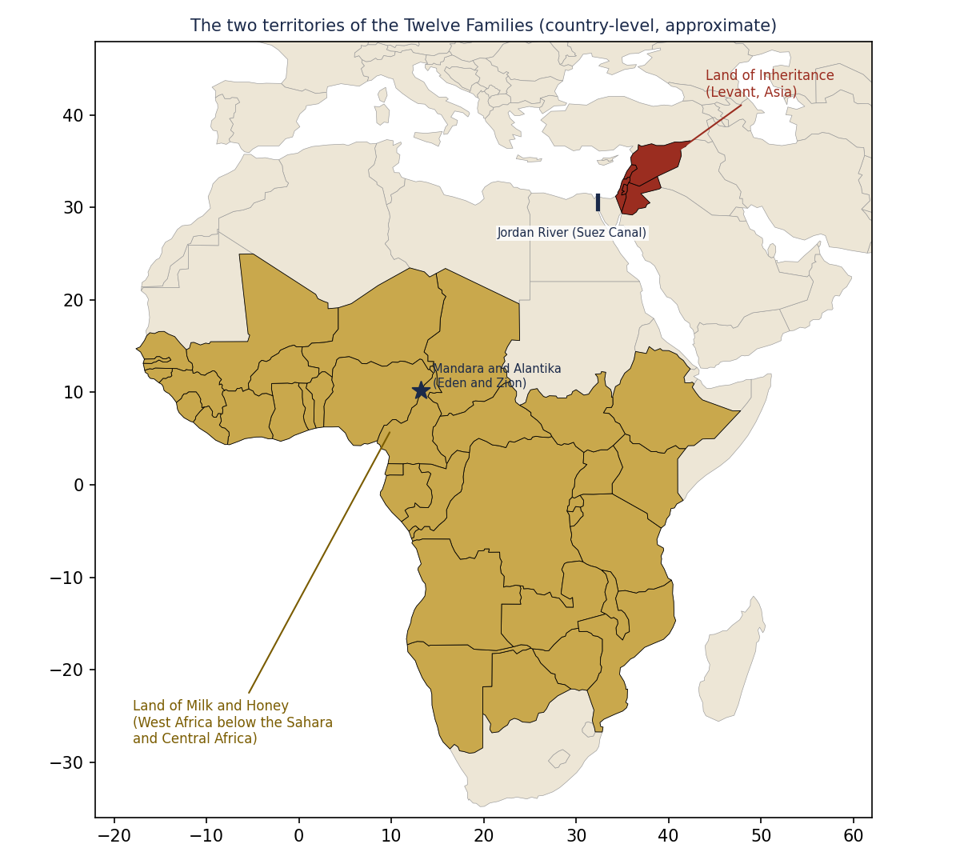
Figure 4. The two territories at country level (approximate). This book concerns the African side, the Land of Milk and Honey, and its Atlantic counterpart.

12. Map data
All site coordinates are in the workbook sheet "Map Sites." They are approximate district-level points picked for illustration, not survey data.

13. Sources used in this book
Tag | Source
Austen1979 | Austen, Ralph A.. The Trans-Saharan Slave Trade: A Tentative Census (in Gemery & Hogendorn, eds., The Uncommon Market). Academic Press (1979).
BerniellLee2009 | Berniell-Lee, G. et al.. Genetic and demographic implications of the Bantu expansion: insights from paternal lineages. Molecular Biology and Evolution 26(7):1581-1589 (2009).
Brownfield2006 | Brownfield, M. E.; Charpentier, R. R.. Geology and Total Petroleum Systems of the Gulf of Guinea Province of West Africa. U.S. Geological Survey Bulletin 2207-C (2006).
Bullard1965 | Bullard, E.; Everett, J. E.; Smith, A. G.. The fit of the continents around the Atlantic. Philosophical Transactions of the Royal Society A 258:41-51 (1965).
Caby1989 | Caby, R.. Precambrian terranes of Benin-Nigeria and northeast Brazil and the Late Proterozoic south Atlantic fit. Geological Society of America Special Paper 230:145-158 (1989).
Castro2001 | Castro, Yeda Pessoa de. Falares africanos na Bahia. Academia Brasileira de Letras / Topbooks (2001).
Eltis2010 | Eltis, David; Richardson, David. Atlas of the Transatlantic Slave Trade. Yale University Press (2010).
Fairhead1991 | Fairhead, J. D.; Binks, R. M.. Differential opening of the Central and South Atlantic Oceans and the opening of the West African rift system. Tectonophysics 187:191-203 (1991).
Fairhead2009 | Fairhead, James; Leach, Melissa. Amazonian Dark Earths in Africa? (in Woods et al., eds., Amazonian Dark Earths: Wim Sombroek's Vision). Springer (2009).
Figueiredo2009 | Figueiredo, J. et al.. Late Miocene onset of the Amazon River and the Amazon deep-sea fan. Geology 37:619-622 (2009).
Glaser2004 | Glaser, Bruno; Woods, William I. (eds.). Amazonian Dark Earths: Explorations in Space and Time. Springer (2004).
Gouveia2020 | Gouveia, M. H. et al.. Origins, Admixture Dynamics, and Homogenization of the African Gene Pool in the Americas. Molecular Biology and Evolution 37(6):1647-1656 (2020).
Greenberg1963 | Greenberg, Joseph H.. The Languages of Africa. Indiana University Press (1963).
Guiraud1992 | Guiraud, R.; Maurin, J.-C.. Early Cretaceous rifts of Western and Central Africa: an overview. Tectonophysics 213:153-168 (1992).
Holm1988 | Holm, John. Pidgins and Creoles (2 vols.). Cambridge University Press (1988).
Hoorn2010 | Hoorn, C. et al.. Amazonia through time: Andean uplift, climate change, landscape evolution, and biodiversity. Science 330:927-931 (2010).
Ledru1994 | Ledru, P. et al.. Markers of the last stages of the Palaeoproterozoic collision: evidence for a 2 Ga continent involving circum-South Atlantic provinces. Precambrian Research 69:169-191 (1994).
Levtzion1981 | Levtzion, Nehemia; Hopkins, J. F. P. (eds.). Corpus of Early Arabic Sources for West African History. Cambridge University Press (1981).
Lipski2005 | Lipski, John M.. A History of Afro-Hispanic Language. Cambridge University Press (2005).
Micheletti2020 | Micheletti, S. J. et al.. Genetic Consequences of the Transatlantic Slave Trade in the Americas. AJHG 107(2):265-277 (2020).
Milesi1992 | Milesi, J.-P. et al.. Early Proterozoic ore deposits and tectonics of the Birimian orogenic belt, West Africa. Precambrian Research 58:305-344 (1992).
Oliver2009 | Oliver, Jose R.. Caciques and Cemi Idols: The Web Spun by Taino Rulers between Hispaniola and Puerto Rico. University of Alabama Press (2009).
Turner1949 | Turner, Lorenzo D.. Africanisms in the Gullah Dialect. University of Chicago Press (1949).
VanSertima1976 | Van Sertima, Ivan. They Came Before Columbus. Random House (1976).
Vansina1990 | Vansina, Jan. Paths in the Rainforests. University of Wisconsin Press (1990).
Wegener1915 | Wegener, Alfred. Die Entstehung der Kontinente und Ozeane (Eng. trans. The Origin of Continents and Oceans, Dover 1966). Vieweg (1915).

